**Establishing a Robust Approach to Adding Critical Ecological Credibility to Stock Assessments**

**Tom Carruthers, Yanjun Wang, Divya Varkey, et al…**

**Introduction**

Stock assessments are the primary means of providing management advice for data-moderate and data-rich stocks in Canada. Stock assessment aims to characterize historical population and fishery dynamics to quantify stock status, reference points and undertake projections of candidate management options. Conventional stock assessments generally assume a single discrete stock. In this regard, conventional stock assessment is generally poorly suited to modeling species with more complex dynamics and does not account for important ecosystem considerations. For example, there is evidence for density-dependent natural survival of haddock in the George’s Bank (refs) and evidence for predator-prey dynamics among Newfoundland cod and shrimp (refs). However these processes cannot be estimated in the conventional stock assessment frameworks.

Ecosystem models, while useful for characterizing hypotheses, have rarely been used to provide management advice because they tend to be very complex, rely on a large number of assumptions and hence struggle to pass peer review. Attempts to build intermediate levels of complexity into stock assessments have proven challenging because estimating all the various aspects simultaneously is numerically unstable – the estimation is too flexible and there are too many plausible solutions given the data available. Hence the current status quo limits science to what is technically feasible, not what is scientifically credible.

Expectation Maximization (EM, Dempster et al. 1977; Sammaknejad et al. 2019) is an established approach for solving complex problems with latent variables that are not directly informed by data, such as density dependent survival. Surprisingly, EM has not yet been used in stock assessment to estimate ecosystem and biological phenomena despite the high degree of promise in the method. Applying EM in this context would use a conventional stock assessment model but place an ‘additional model’ (e.g. density dependence, species-interactions) between runs of the assessment model (Figure 1). After each iteration of the assessment model run, the input parameters are adjusted slightly according to the predictions of the additional model and the process continues until the method converges on a stable solution.

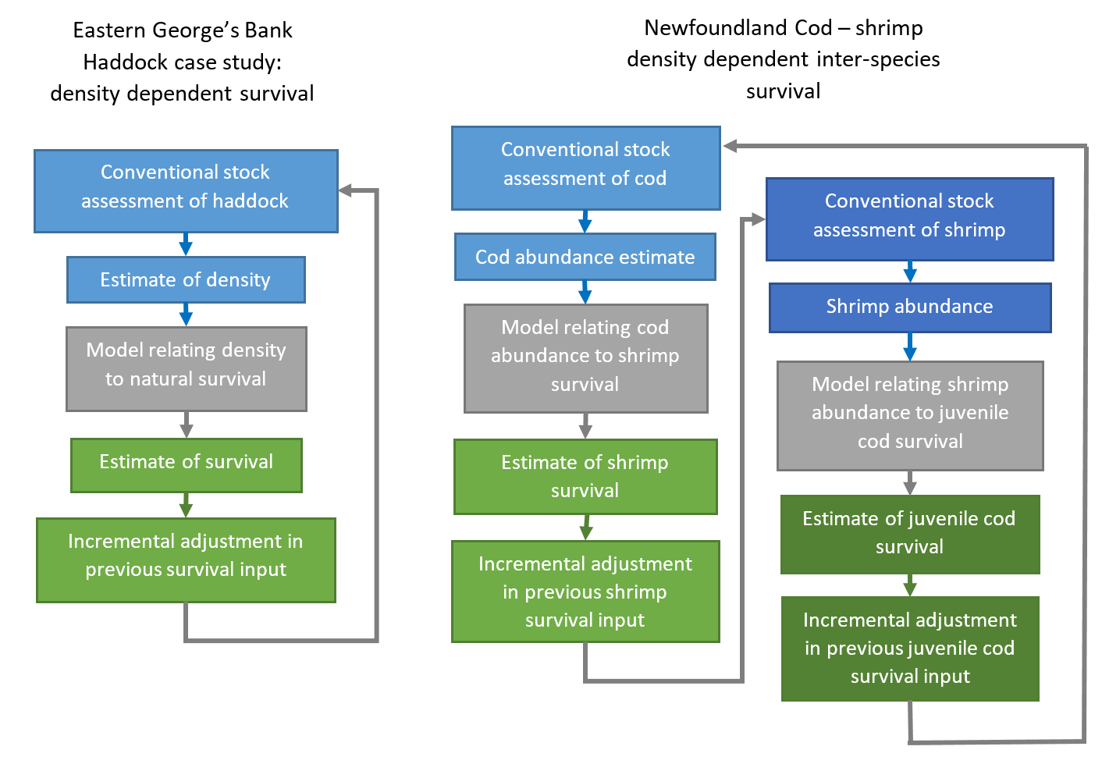Figure 1. Simplified schematic of the EM approach applied to single stock (EGB haddock) and multi-stock (Newfoundland cod-shrimp) case studies.

The stable solution arising from this EM-Assessment approach can be subject to typical model diagnostics such as model selection criteria, profiling over the parameters of the additional model etc. Because the EM approach uses a conventional stock assessment (e.g., stock synthesis, WHAM, ASAP, RCM) no changes to the conventional tools is required and there is unlimited flexibility in the specification of the additional model. Modern stock assessments also run sufficiently quickly (less than a few seconds) to make EM practically viable. Previous applications of EM (e.g.,Carruthers et al. 2019) found highly complex models involving many hundreds of populations could converge on a stable solution in less than 15 iterations (Figure 2).

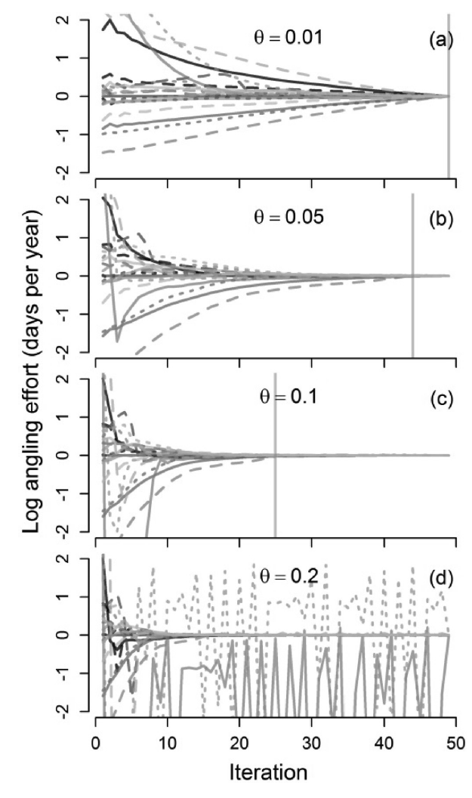

Figure 2. Convergence of the EM algorithm on stable angling effort across more than 700 populations of B.C. trout (Carruthers et al. 2019). The parameter theta is the percentage change in the adjustment of parameters.

We propose a study to test the EM-Assessment approach by simulation and then application to real data for single species and multi-species case studies.

< EGB Haddock case study >

* Background
* Data
* Models / Assessments
* Why this is necessary (e.g. we can make more credible projections using the estimated relationships between survival and abundance, has implications for reference points etc)

< NFLD Lobster – shrimp case study >

* Background,
* Data
* Models / Assessments
* Why this is necessary.

**Tasks**

1. Use fishery data to fit population dynamics models for Haddock, Cod and shrimp
2. Propose plausible relationships between density and survival
3. Simulate data for each stock
4. Write an EM-Assessment tool and document in an R package
5. Test the EM-Assessment tool: can it correctly identify the simulated relationships between abundance and survival. Do model selection criteria / likelihood profiling work?
6. Apply the approach to the real fishery data
7. Write up a peer-review article.

**Deliverables**

???

**Timeline**

2024-2025?

**Products**

* R package
* Project splash page
* Peer-reviewed article

**Advances**

* First application of EM to assessment
* A specific case of a non-linear optimization within the EM framework
* First multi-species stock assessment approach using conventional tools that could meet requirements of peer review
* Defines a reproducible framework for doing more complex assessments using any assessment model.

**Budget**

Tom (50k), Yanjun (25k)??

**References**

Carruthers, T.R. et al. 2018. Landscape scale social and ecological outcomes of dynamic angler and fish behaviours: processes, data, and patterns. Canadian Journal of Fisheries and Aquatic Sciences. Doi: 10.1139/cjfas-2018-0168

Dempster, A.P.; Laird, N.M.; Rubin, D.B. 1977. "Maximum Likelihood from Incomplete Data via the EM Algorithm". Journal of the Royal Statistical Society, Series B. 39 (1): 1–38.

Sammaknejad, N., Zhao, Y., Huang, B. 2019. A review of the Expectation Maximization algorithm in data-driven process identification. Journal of Process Control, 73: 123-136. Doi: 10.1016/j.jprocont.2018.12.010.